Automatically supplying production lines

Dynamic AGV revolutionises electronics and precision mechanics production

Melkus Mechatronic developed a dynamic AGV for PCB and small parts containers with automated load transfer, the Melkus Rack Stacker BLS4060 autonomous transport robot, for flexible use in precision mechanics and electronics production.

Goeming/Salzburg, 10 March 2025 – The dynamic small AGV Melkus Rack Stacker BLS4060 is specially tailored to the high demands of electronics production or precision mechanics and optimised for transporting PCB magazines and classic Euro boxes. Thanks to its extremely compact design, it can efficiently support the production process in production environments where space is at a premium.

Complex material flow
Electronics production is complex. Before a ready-to-install module is finished, it needs to pass numerous stations and processes, some of them several times. PCBs and the components to be installed on them are assembled at manual workstations and automatic machines - often both in succession - and then soldered in separate stations and finally tested and packaged. The resulting product needs to be transported to numerous stations, often also to buffer stores in between and finally to the warehouse. The production of precision mechanical assemblies and devices is similarly complex.

The material supply and disposal of the individual stations in electronics production must be carried out precisely in a very limited space. Until now, this has often resisted automation, tying up valuable personnel.

Seamless automation
The Melkus Rack Stacker BLS4060 is suitable for transporting and handling both special PCB magazines and classic Euro boxes up to 400 x 600 mm in size. It closes the automation gap between component and finished product storage, assembly workstations, SMT machines and soldering stations.

The innovative lift system of the Melkus Rack Stacker was specially developed for transport and transfer situations in electronics manufacturing or precision mechanics production. It enables the flexible transfer of transported goods to transfer stations at different heights from 320 mm to 1800 mm. Nevertheless, the innovative AGV with an overall height of 1950 mm fits through any standard door. Precise and efficient transfer takes place on both sides via an integrated conveyor belt system with clamping jaws for gripping the load carriers. An optionally integrated RFID scanner enables automatic identification of the containers. This facilitates seamless automation of the entire transport chain, from retrieval to provision.

The task-specific, ESD-compliant autonomous transport vehicle has an extremely small footprint of 719 x 676 mm. As it can turn while stationary, navigation and load transfer can efficiently take place even in confined spaces. The Melkus Rack Stacker is based on the tried-and-tested compact Melkus c4060 transport robot, which uses LIDAR scanners and SLAM navigation to find its way anywhere without the need for special installations. The vehicle communicates via WLAN and can be integrated into any fleet management system thanks to VDA5050 compatibility.

The Melkus Rack Stacker's LiFePO4 batteries enable up to eight hours of uninterrupted transport with maximum flexibility. Its two LIDAR scanners ensure all-round personal protection. Durable components and a modular design help minimise maintenance costs.
Image Captions:

The Melkus BLS4060 compact AGV rack stacker for electronics and precision mechanics production can automatically remove or set down loads at heights of 320 mm to 1800 mm and still fit through any standard door.  All images: Melkus Mechatronic | 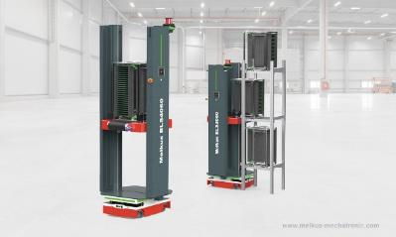
The Melkus Rack Stacker BLS4060 has been designed for the space-saving and efficient transport of PCB magazines and Euro boxes up to 600 x 400 mm. | 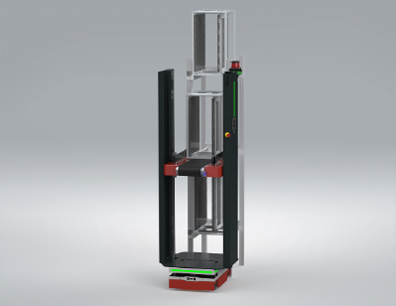
Martin Lindner, CEO, Melkus Mechatronic:  "Efficiency is the key to savings. The Melkus Rack Stacker BLS4060 is our contribution to increasing flexibility and efficiency in electronics and precision mechanics production." | 

About Melkus Mechatronic
Melkus Mechatronic GmbH is an innovative technology company based in Salzburg. With more than ten years of experience in the field of AGVs and mobile robotics, it provides customers with highly available AGVs for flexible in-house transport with maximum reliability. Swiftly installed and commissioned, these enable Melkus operators to organise their intralogistics more efficiently and to establish resource-saving processes. Melkus employs highly qualified and committed staff and offers a range of six AGVs for a wide variety of applications. www.melkus-mechatronic.com

